Developing a Concept Map
Institution:
Name:

Developing a Concept Map
A concept map is a graphical representation of the various strategies of concept that is used in developing specific knowledge in a given area. It is more of a strategic development plan where one can develop a concept based on a specific knowledge field to establish a strategy in the long run success (Cañas et al., 2015). Essentially a business company can also use a concept map to identify the specific areas of operations that require attention for business improvement. A business can use the concept map to develop strategies and concepts to help in achieving a specific outcome. Ideally, it starts with the main idea and then branches out to other specific topics. A concept map uses the idea of a decision tree where a business strategizes on the specific activities and ideas which requires implementation for business improvement. It can be compared to a strategy only that the concept diagrammatically represents the development of ideas based on specific knowledge (Ong et al., 2018).
Any business requires developing strategies and concepts that are ideally applicable in the business to achieve the specific set goals and objective (Ong et al., 2018). It is an all-around process therefore which requires a business to focus on all aspects of production among other activities in the business. For instance, in a manufacturing company, several activities are critical that every business must focus on when developing a concept map or drawing strategies. Specifically, there are key areas that every completive global manufacturing firm need to focus on to develop a concept map that will effectively assist the business in achieving its goals and objectives. A business must set its goals and objectives and focus on the product, customers, profit and competitors (Cañas et al., 2015). Below is an example of a concept map that a global manufacturing company can develop for long term survival.

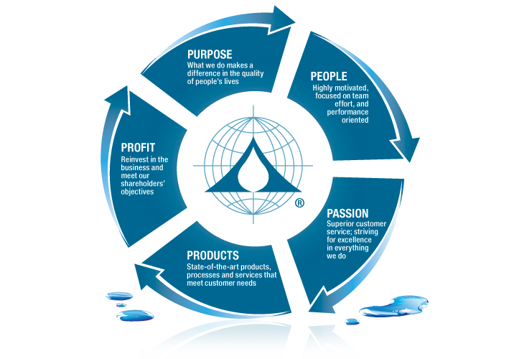
There are different factors that business must consider when drawing a concept map. Defining the purpose of the business by establishing the goal and objectives of the business, by focusing on the product and market. A business always operates under risk (Ong et al., 2018). It is important therefore to consider and identify the various types of a risk that is prevalent in business that a business must work on. A business company, therefore, engages in risk management activities by identifying the various risk management strategies to be included in the concept map. It is important also to establish the different logistics considerations for the business. Ideally, any business must primarily focus on cutting down the cost of operations. In this regards, a concept map involves cost-benefit analysis in the determination of the financial planning of the business. There is the need to develop different marketing strategies that the company will implement in attaining the market by outdoing their competitors (Ong et al., 2018).
Based on the current development the concept map requires proper consideration of technology and other dynamics in the market such as globalization. Some other new strategies and improvements in the business that requires to be developed in the concept map include globalization (Cañas et al., 2015). There are various global opportunities such as global market for consumer goods as well as the associated risks. In other words, a concept map includes an analysis of the business to identify the major areas of operations and hence the development of ideas and strategies that can assist in improving the performance of the business. This will include routine operations and the strategic activities of the business such as production. Logistics, cost analysis, risk management, competition, globalization among others. From the above example, profit purpose people, passion and products are key ideas to success and improvement of the business. The business, therefore, needs to focus on the areas for overall success.

References
Cañas, A. J., Novak, J. D., & Reiska, P. (2015). How good is my concept map? Am I a good Cmapper?. Knowledge Management & E-Learning: An International Journal, 7(1), 6-19.
Ong, J. C., Arand, D., Schmitz, M., Baron, K., Blackburn, R., Grandner, M. A., ... & C. Dawson, S. (2018). A Concept Map of Behavioral Sleep Medicine: Defining the Scope of the Field and Strategic Priorities. Behavioral sleep medicine, 16(6), 523-526.

